Shifts in the Relative Abundance of Pheasants Phasianus colchicus in Relation to Protected Areas
Luke Ozsanlav-Harris & Joah Madden
2023-08-17
Table of contents

1. Summary
After release pheasants Phasianus colchicus can disperse into the wider environment with management trying to slow down this diffusion beyond the bounds of the shoot. Protected areas might be sites that dispersing pheasants are attracted too due to respite from shooting and suitable habitat for overwintering and/or breeding. Using tetrad survey data from four county-level bird atlas surveys during 2007-2011 it is possible to assess whether there are relative movements of pheasants towards tetrads with high protected area coverage between the winter and breeding season. We used a generalised linear mixed effects model to examine the relationships between relative pheasant abundance and protected area coverage. We found varying results between the four counties but no strong evidence in any county that there was a net movement of pheasants into tetrads with higher protected area coverage from winter to summer. In fact, we found the opposite in two counties (Cornwall and Devon) with signs of relative shifts in pheasants’ abundance towards tetrads with lower protected area coverage. There are a number of important caveats to this work that we highlight at the end of this report, including the use of coarse categorical data, spatial autocorrelation in the model and the assumption of constant survival within counties.

2. Introduction
Pheasants are released across the UK for shooting during the winter months. After release, pheasants can move away from the release sites (Hill and Ridley 1987) while game management aims to keep the majority of pheasants within areas where shooting will take place (Game Coservation Trust 1996). Protected areas may provide attractive areas for dispersing individuals to move into, providing a refuge from shooting activities or suitable wintering/breeding habitats. Such immigration may be concerning because of the ecological damage that these birds may exert in protected areas via direct negative effects including nutrient enrichment through defecation, predation of local native fauna, trampling damage to flora, vectors of disease and/or supporting local abundances of generalist predators as prey (Madden and Sage 2020; Mason et al. 2020; Sage et al. 2020). One way to assess whether released pheasants are moving into protected areas would be to examine whether there are relative shifts in the abundance of Pheasants from areas where they are released and retained (late-summer to late winter), towards protected areas in the breeding season (late spring/early summer) after shooting and game management has predominantly ceased.
During 2007-2011 the BTO organised volunteer surveys of all UK birds at the tetrad level (2km x 2km squares) during the winter (November to February) and breeding season (April to July) (Balmer et al. 2013). Fieldwork for the survey was carried out in four winters (2007/08–2010/11) and four breeding seasons (2008–11) with a pair of standardized visits to each tetrad in each of the eight survey periods, for more details on the methodology see (Balmer et al. 2013; Gillings et al. 2019). This data set provides a single abundance estimates for Pheasants during the winter and breeding season. Changes in abundance can therefore be examined between winter, when shooting typically takes place, and summer, when breeding takes place but the next cohort of reared pheasants have yet to be released. Between these two time periods the number of pheasants will have decreased overall, due to natural mortality and shooting, to levels ~15% of those released (Madden, Hall, and Whiteside 2018). Therefore, we are interested in changes in the relative abundance, which accounts for mortality. If pheasants are dispersing towards protected areas then we would expect increases in the relative abundance between winter and summer in tetrads containing a higher percentage coverage of protected areas.

3. Methods

3.0.1 Data sets
- BTO tetrad data for the abundance of Pheasants for Cornwall, Devon, Berkshire and Hertfordshire (only counties with abundance data available on their county webpages)
- UK protected area outlines, this included SPAs, SACs, RAMARs and SSSIs
- UK CEH Landcover data (1km x 1km and 25m x 25m spatial resolution) designating each pixel to one of 10 amalgamated habitat categories (Morton et al. 2014)

3.0.2 Spatial Calculations
For each of the tetrads (n = 3442) across the four counties examined we determined the proportion of the 2km x 2km squares that were covered by any type of protected area (see Figure 1) and by each of the 10 habitat classes. The UK CEH land cover data set contains 21 habitat categories but we used an amalgamated version that contained the following 10 habitat categories: broadleaved woodland, coniferous woodland, arable/horticulture, improved grassland, any semi-natural grassland, uplands, saltwater, freshwater, any coastal habitat and Urban/Suburban. We also calculated the Shannon diversity index for habitats in each tetrad with higher index values relating to more diverse and varied habitats within the tetrad.
To account for many protected areas being unimportant to pheasants (e.g. Coastline, Estuaries and Fens) we removed protected areas where the dominant habitat was deemed to be ecologically irrelevant to pheasants. We used the 2007 UK CEH land cover map (25m x 25m spatial resolution) to determine the dominant habitat in each protected area (Morton et al. 2014). Protected area were removed from subsequent analysis if the dominant habitat type was one of the following: ocean, saltwater, freshwater, saltmarsh, bog, urban, suburban, fen/marsh/swamp, inland rock, supra-littoral sediment, supra-littoral rock, littoral sediment or littoral rock. This meant the following habitat types were kept: broadleaved woodland, coniferous woodland, arable/horticulture, heather, heather grassland, acid grassland, rough grassland, improved grassland, neutral grassland and calcareous grassland. Occasionally a single designated site was composed of multiple distinct and disconnected polygons. In these instances the dominant habitat type in each polygon was calculated and sites excluded or included at the polygon level. Finally we calculated the proportion of each 2km x 2km tetrad that was covered by these remaining ecologically relevant protected areas (see appendix: Figure 5).
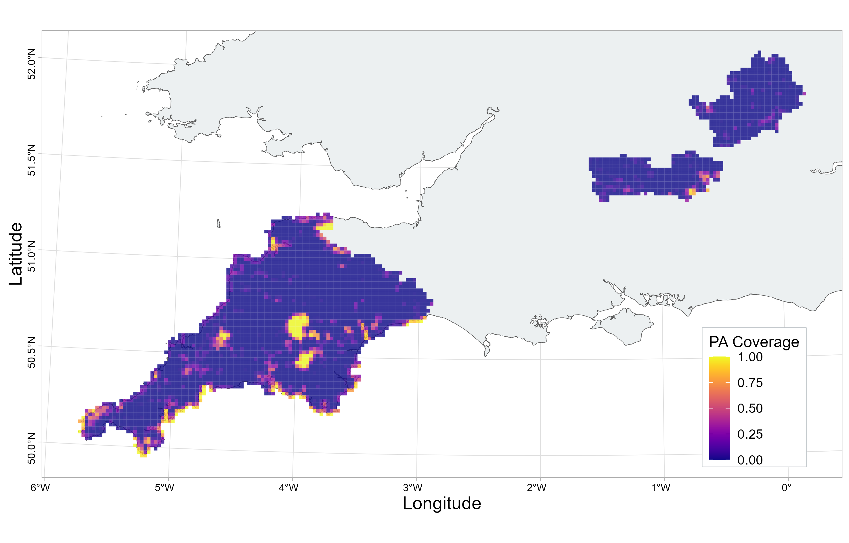
Figure 1: The proportion of each tetrad in Cornwall, Devon, Berkshire and Hertfordshire covered by protected areas

3.0.3 Statistical Modelling
Prior to carrying out statistical modelling the abundance data had to be standardised across counties since it was recorded differently for each county. Abundance data were continuous for Cornwall and remained unaltered for modelling. For Devon, Berkshire and Hertfordshire abundance was categorical and these categories were also different for each of the three counties. Therefore we used the midpoint value for each category for use in statistical modelling. Therefore each tetrad had a single continuous value of abundance for winter (Figure 2) and in summer (Figure 3).
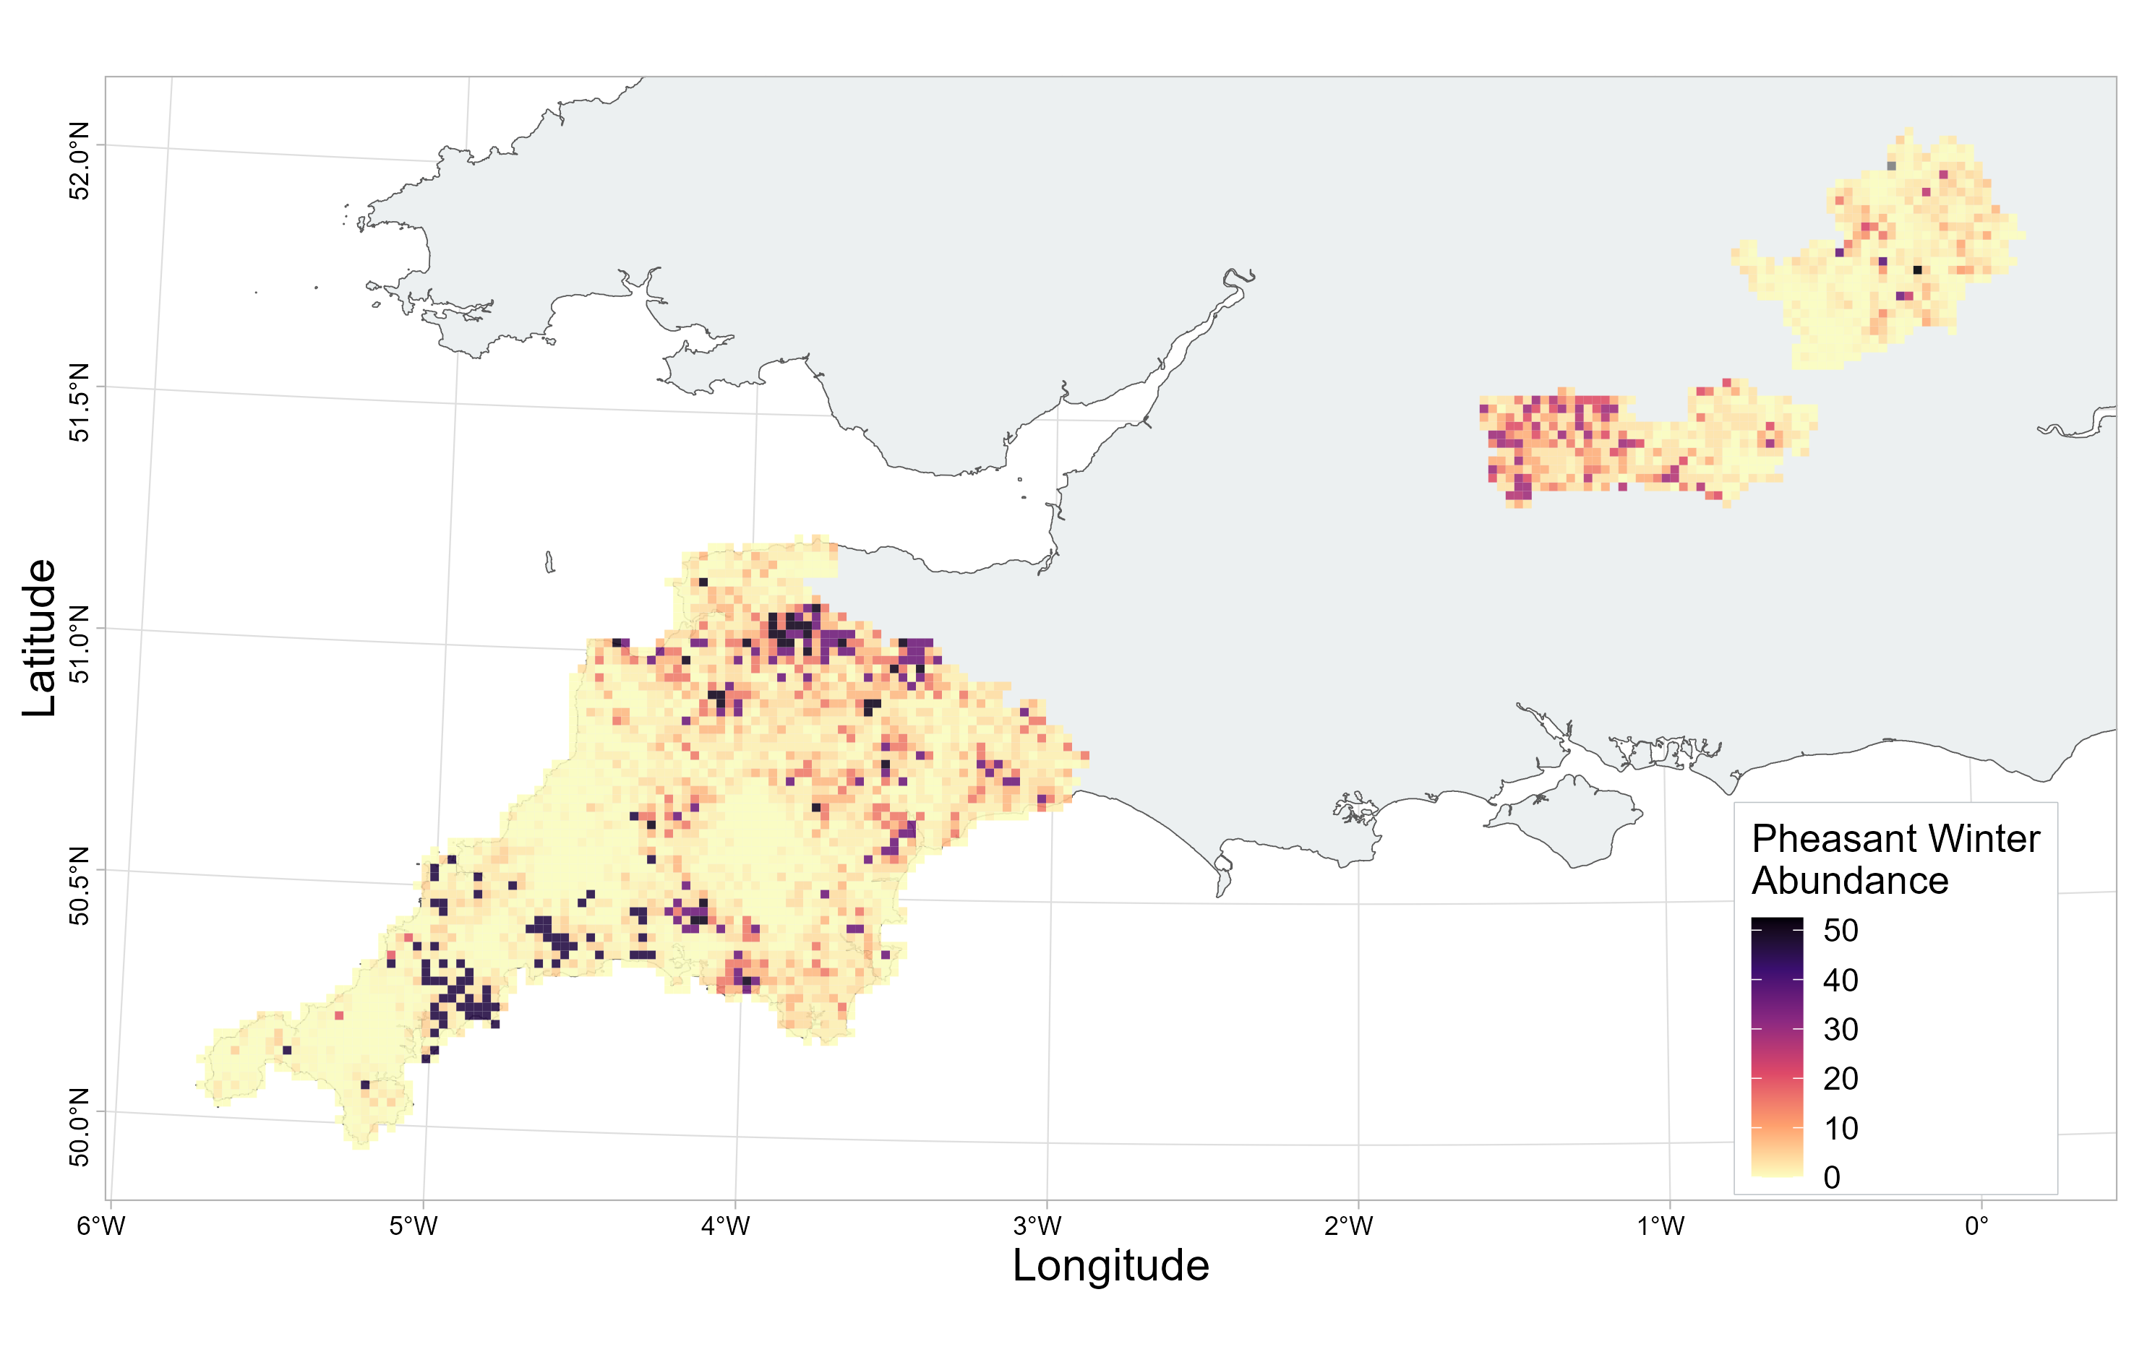
Figure 2: Abundance of pheasants within each survey tetrad during the winter BTO 2007-2011 bird atlas survey

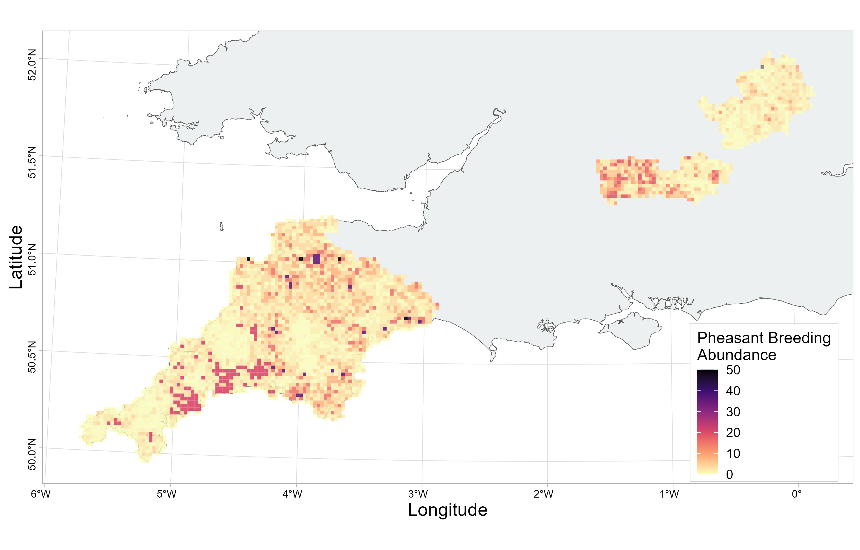
Figure 3: Abundance of pheasants within each survey tetrad during the summer BTO 2007-2011 bird atlas survey
We then converted all of these continuous abundance measures into abundance measures that were relative to the total number of pheasants in the same county using equation 1. Where $Abund_{i,c,s}$ is the abundance for the $i^{th}$ tetrad in county $c$ during season $s$. In summary, the abundance for a given tetrad was divided by the total abundance for all tetrads in the same country and during the same season (winter or summer). This relative abundance metric was chosen to model with since it takes into account the mortality between winter and summer, meaning that relative abundance would be constant for a given tetrad if there is no net immigration or emigration and survival is constant across the county.
$$RelAbund=\frac{Abund_{i,c,s}}{∑Abund_{c,s}} \left(1\right)$$
To model relative abundance as a function of covariates we used a tweedie generalised linear mixed effects models with a log link function in the R package glmmTMB (Brooks et al. 2017). The tweedie distribution is used for data that are right-skewed, positive and contain zeros meaning gaussian and gamma distributions can not be used (Kurz 2017). Fixed covariates in the model were protected area coverage (continuous value from 0-1), survey season (two-level category: winter or summer), county (four-level category: Berkshire, Cornwall, Devon and Hertfordshire) and the proportional habitat coverage of ten different habitat (separate continuous value from 0-1 for: broadleaf woodland, coniferous woodland, arable, improved grassland, semi natural grassland, mountain/uplands, saltwater, freshwater, coastal and built up). An interaction term was fitted between protected area coverage, season and county to allow the relationship between relative abundance and protected area coverage to vary between seasons and counties. To incorporate the dependency between observations from the same tetrad, we used the unique tetrad ID as a random intercept. We ran this analysis a second time, in this instance replacing protected area coverage with ecologically relevant protected area coverage (continuous value from 0-1). This was done to determine whether the inclusion of ecologically irrelevant protected attracted areas biased the results.
We predict that the relationship (intercept and slope) between relative abundance and protected area coverage will be the same for winter and summer if there is no net movement of pheasants in relation to the protected area coverage of a tetrad. If there is a net movement of pheasants into tetrads with higher protected area coverage between winter and summer then we expect that the relative pheasant abundance will be higher in summer compared to winter at higher protected area coverage.

4. Results
As expected, pheasant abundance was strongly influenced by local habitats. There were significant positive relationships (given as [β= estimate: 95% confidence interval]) between relative abundance and the proportion of the tetrad covered by habitat diversity [β= 0.252: 0.073, 0.432], broad leafed woodland [β= 0.024: 0.017, 0.031], arable [β= 0.015: 0.012, 0.019] and improved grassland [β= 0.005: 0.002, 0.008] (variables arranged with largest parameters estimate first). Conversely, there were significant negative relationships between relative abundance and the proportion of uplands [β= -0.020: -0.027, -0.013], freshwater [β= -0.019: -0.035, -0.003], built up areas [β= -0.016: -0.020, -0.012] and semi natural grassland [β= -0.014: -0.019, -0.010]. The proportion of coniferous woodland [β= -0.002: -0.009, 0.007], saltwater [β= 0.004: -0.001, 0.017], and coastal [β= 0.001: -0.008, 0.011] did not have significant relationships with relative abundance.
The relationships between relative pheasant abundance and protected area coverage varied between seasons and counties (Figure 4). For Berkshire, the regression lines between relative abundance and protected area coverage did not significantly differ between winter and summer, in terms of intercept or slope, suggesting no seasonal changes in relative abundance in relation to protected area coverage. In addition the regression lines did not differ from zero for winter [β= -0.03: -1.07, 1.01] or summer [β= 0.26: -0.76, 1.27]. Overall this indicates no movement either towards or away from protected areas and pheasant abundance is evenly distributed in relation to protected area coverage. For Cornwall, the regression lines between relative abundance and protected area coverage differed significantly between winter and summer, in terms of both intercept [β= 0.40: 0.31, 0.49] and slope [β= -0.68: -1.20, -0.15]. The intercept was higher in summer suggesting higher relative abundance at lower protected area coverage compared to winter but the slope was more negative compared to winter suggesting these differences diminished at higher protected area coverage. In addition the regression lines for winter [β= -0.86: -1.38, -0.34] and summer [β= -1.54: -2.05, -1.03] were both significantly negative. Overall this indicates some movement away from protected areas between seasons and that relative pheasant abundance is higher where protected area coverage is lower in Cornwall. For Devon, the regression lines between relative abundance and protected area coverage differed significantly between winter and summer in terms of intercept [β= 0.14: 0.07, 0.21] but not slope [β= 0.13: -0.37, 0.61]. The intercept was higher for summer suggesting higher relative abundance at lower protected area coverage compared to winter. The slopes did not significantly differ but at higher protected area coverage the difference in relative abundance did not differ between seasons. In addition the regression lines for winter [β= -0.64: -1.15, -0.13] and summer [β= -0.52: -1.00, -0.03] were both significantly negative. Overall this indicates some movement away from protected areas between seasons and that relative pheasant abundance is higher where protected area coverage is lower in Devon. For Hertfordshire, the regression lines between relative abundance and protected area coverage differed significantly between winter and summer in terms of both intercept [β= 0.15: 0.06, 0.25] and slope [β= 2.00: 0.01, 3.98]. The intercept was higher for summer suggesting higher relative abundance at lower protected area coverage compared to winter. The slope was less negative in summer compared to winter but both of the individual slopes for winter [β= -2.40: -4.89, 0.09] and summer [β= -0.40: -2.75, 1.95] were insignificant. Overall this indicates some movement towards protected areas between seasons and that relative pheasant abundance is evenly distributed in relation to protected area coverage. However, since the confidence interval for the estimate of difference between slopes nearly overlapped we would suggest there is only weak evidence for this interpretation.
The relationships between relative pheasant abundance and ecologically relevant protected area coverage were similar to the relationships described above (Figure 6). For Berkshire, Devon and Hertfordshire there were only small changes to parameter estimates and this resulted in no changes to the interpretation of the results. For Cornwall, the regression lines between relative abundance and protected area coverage no longer differed significantly between winter and summer, in terms of slope [β= 0.30: -0.68, 1.28]. This changes the previous interpretation slightly and indicates that the movement away from protected areas between winter and summer is weaker than earlier indicated.
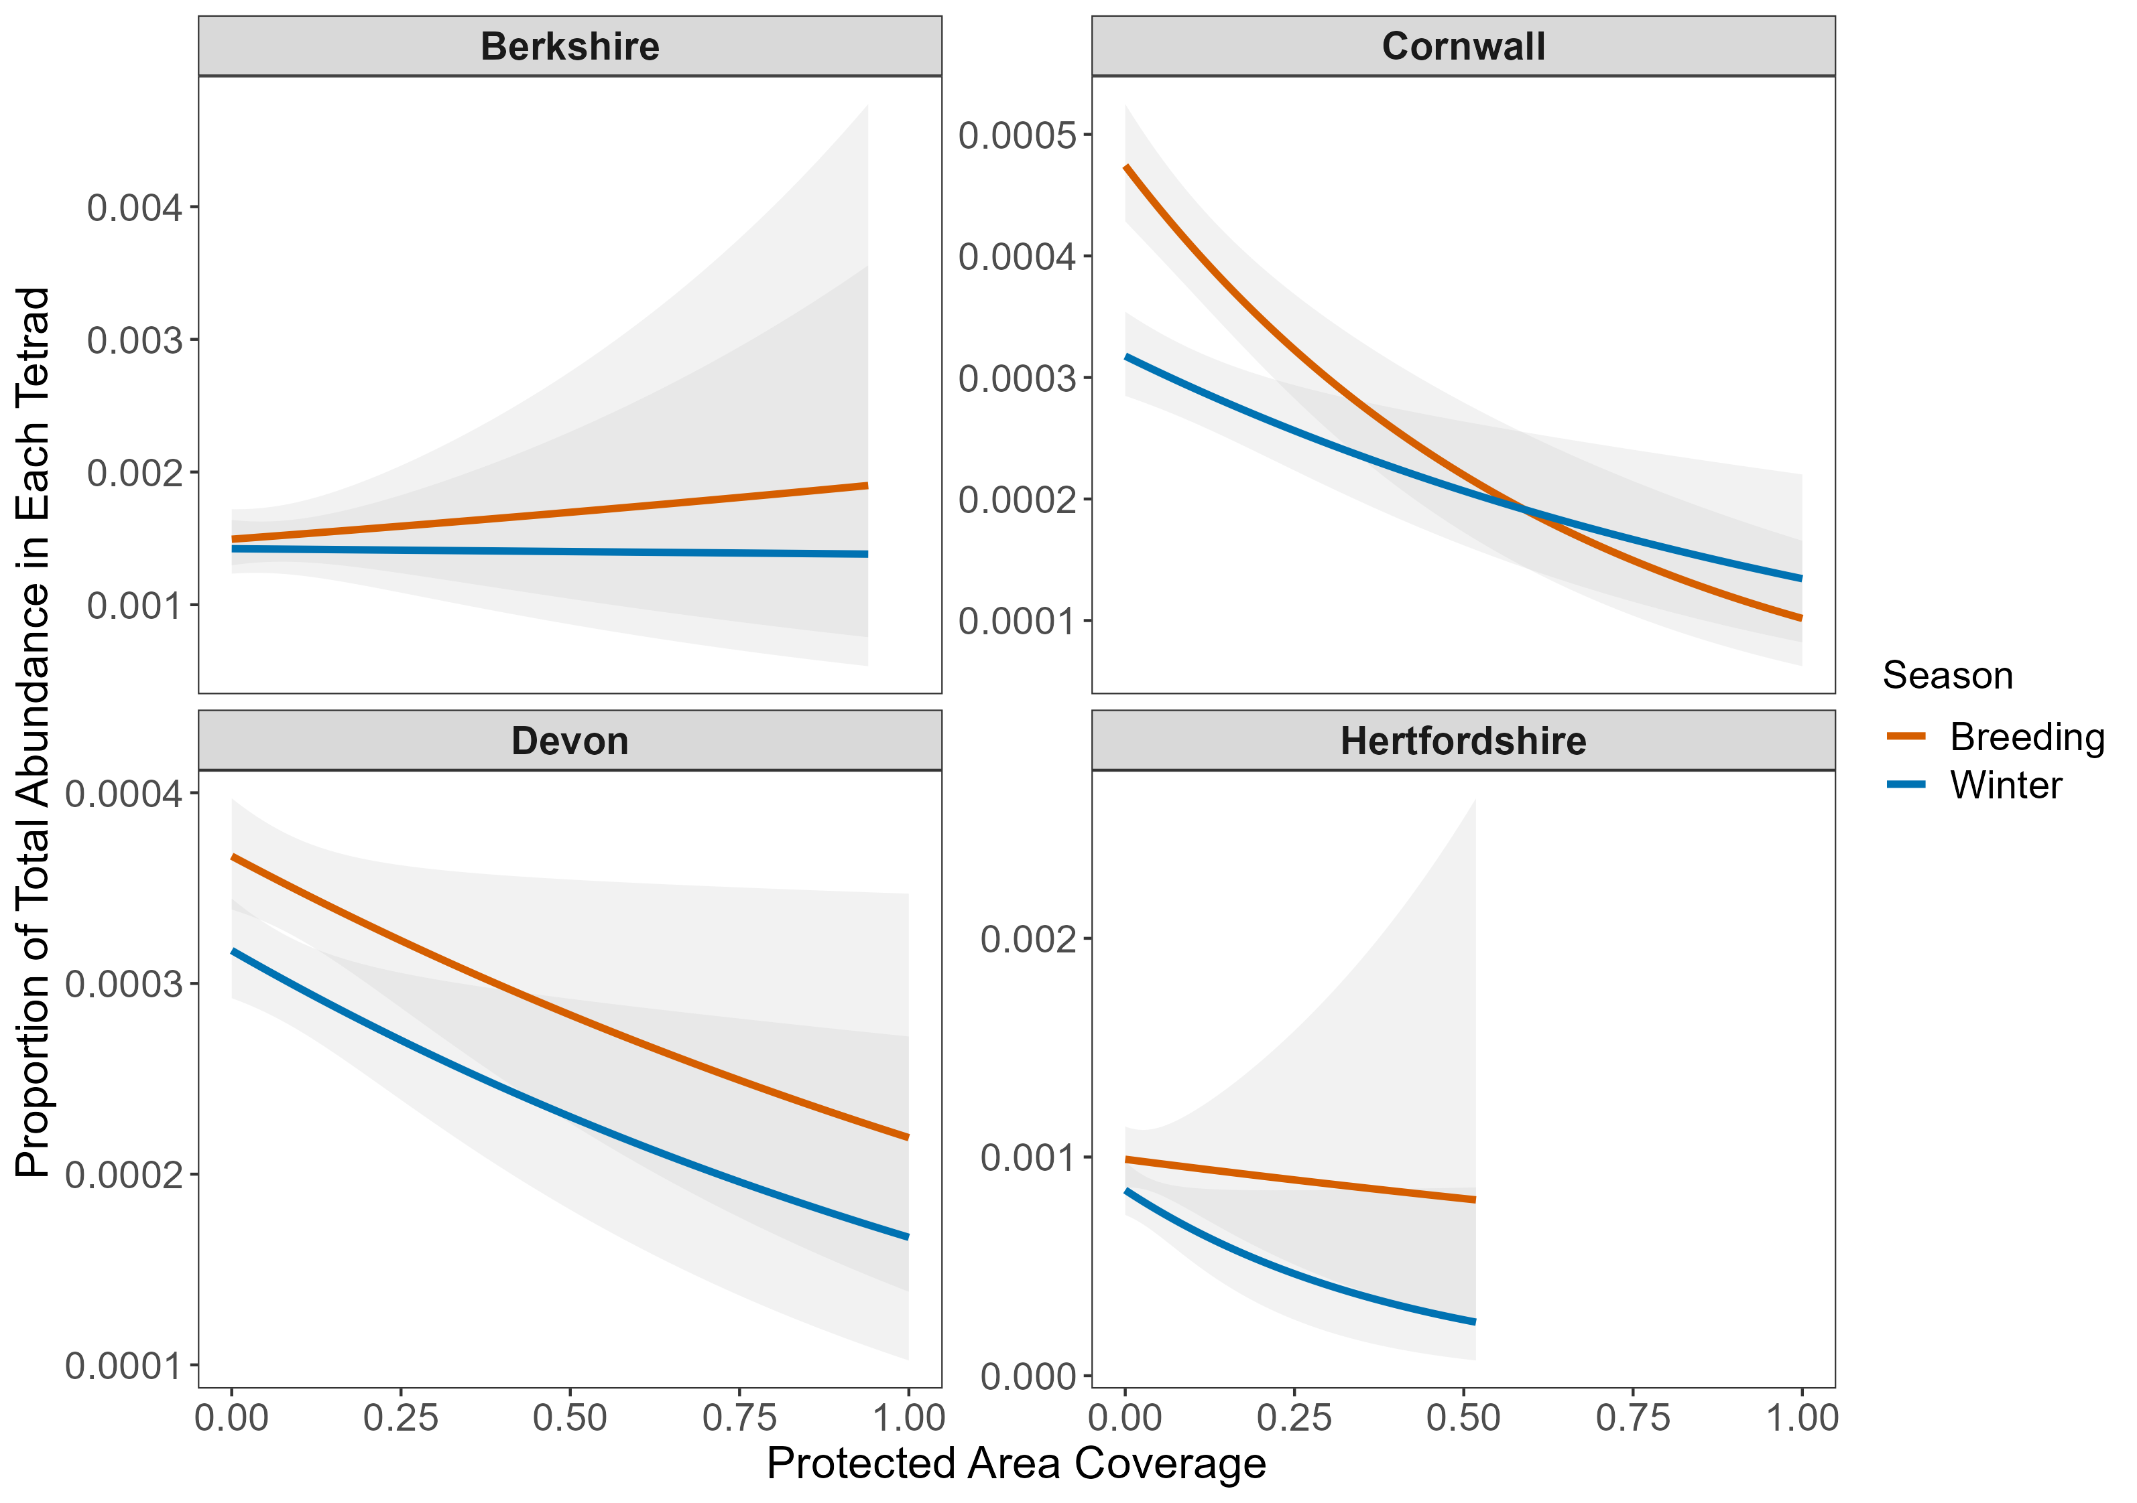
Figure 4: Relationship between relative pheasant abundance and protected area coverage for winter and summer across four counties. The regression lines for Berkshire and Hertfordshire are censored at the maximum protected area coverage for a tetrad in those counties. Note: the y-axis scales varies by county.

5. Discussion
While controlling for habitat types in our analysis we found some ecologically expected relationships, e.g. higher abundance with more broad-leafed woodland and lower in built up areas. Habitat diversity index was one of the strongest drivers overall of relative pheasant abundance and this likely reflects Pheasants strong preference for edge habitat at the interface of woodland and open areas (Hill and Ridley 1987). These results demonstrate that this broad-scale approach has been able to capture known ecological drivers of pheasant abundance.
In Berkshire the relationship between protected area coverage and relative abundance did not differ between seasons and therefore there is no evidence to support a net movement of pheasant in relation to protected area coverage (Figure 4). For the other three counties, Devon, Cornwall and Hertfordshire, the intercept values were higher for summer (Figure 4). This suggests that at 0% protected area coverage relative abundance was greater in summer. In Devon and Cornwall the regression lines converge meaning at higher protected area coverage there is no difference in relative abundance between winter and summer and suggestive of a movement away from protected areas. While for Hertfordshire the lines diverge, suggestive of movement towards protected areas, but the confidence intervals become very large at higher protected area coverage so it is hard to make this interpretation with any confidence.
For Devon and Conrwall our results overall suggest that there is a net movement of pheasants into tetrads with lower protected area coverage. One explanation for this result is that birds are moving back towards their release sites, which are likely to be in tetrads with lower protected area coverage, after spending the winter further from the release site. This can be thought of as a kind of natal site philopatry (Greenwood 1980) where the release pen is akin to the natal site (Burnside, Collar, and Dolman 2017). Another explanation of our results is that survival may not be constant within a county as we presumed. Our results could therefore be explained by higher survival in tetrads with low protected area coverage which would cause the observed higher relative summer abundance in tetrads with lower protected are coverage. However it is hard to determine how survival may vary with protected area coverage due to the association with game management intensity. In low protected area coverage game management intensity is likely to be higher which can increase the survival of released pheasants, e.g. due to supplementary feeding, predator control and anti-helminthic treatment (Madden, Hall, and Whiteside 2018). At higher protected area coverage there are likely fewer of these survival boosting interventions but shooting intensity is also likely lower which would itself increase survival.
Overall we do not find strong evidence of attraction of pheasants towards protected areas in the UK (although there is weak evidence of this in Hertfordshire). This broad-scale analysis suggests that pheasants dispersal is not biased towards protected areas. It should be noted though that are still pheasants present in tetrads with high protected are coverage as dispersal can still occur into these areas. Further analysis is required to determined the densities of pheasants that occur in protected areas areas and over what area this occurs in order to make an accurate assessment of potential ecological damage.

6. Limitations
- Midpoints of Categorical Variables: for Devon, Berkshire and Hertfordshire we had to take the midpoint of abundance categories (e.g. 1-5 birds). This means that increases in abundance within the same category result in no change to the abundance measured we used. However even small increases at the extremes of a category can results in a large increase in abundance as the value moved to a higher category.
- Risk of under-recording of gamebirds: surveyors may not consider gamebirds to be ‘real’ or ‘wild’ birds (although they are meant to be recorded in the atlas survey). However this would most likely only add noise to the data and there is no reason to think that naïve recorders have spatially biased their data collection with respect to this study.
- Surveys 10+ years ago: The surveys for the BTO bird atlas were conducted between 2007 and 2011 and while the behavior of released pheasants is unlikely to have changed a lot since this period it is worth highlighting that this analysis represents movement of pheasants from more than 12 years ago.
- Effects of naturalized breeding populations of pheasants: there is likely to be very small ‘wild’ breeding population of pheasants in undisturbed and unshot (but also unkeepered) PAs. These birds are known to have higher survival in than released birds and therefore may mask some potential patterns in the data.
- No data on release sites: we did not include data on release sites but since we examined changes in relative abundance we would expect that tetrads containing release sites to have higher relative abundance in both seasons.
- Spatial autocorrelation: there was evidence of spatial autocorrelation in the residuals of the model. This violates one of the assumptions of the model, that the residuals are independent and identically distributed. This can bias parameter estimates and inflate type I error rates (falsely rejecting the null hypothesis of no effect) (F. Dormann et al. 2007).

Bibliography
Balmer, Dawn, Simon Gillings, B. J. Caffrey, Robert L Swann, I. S. Downie, and R. J. Fuller. 2013. 200711: The Breeding and Wintering Birds of Britain and Ireland. BTO Books, Thetford.
Brooks, Mollie E., Kasper Kristensen, Koen J. van, Arni Magnusson, Casper W. Berg, Anders Nielsen, Hans J. Skaug, Martin Maechler, and Benjamin M. Bolker. 2017. “glmmTMB Balances Speed and Flexibility Among Packages for Zero-Inflated Generalized Linear Mixed Modeling” 9. https://doi.org/10.32614/RJ-2017-066.
Burnside, Robert J., Nigel J. Collar, and Paul M. Dolman. 2017. “Comparative Migration Strategies of Wild and Captive-Bred Asian HoubaraChlamydotis Macqueenii.” Ibis 159 (2): 374–89. https://doi.org/10.1111/ibi.12462.
F. Dormann, Carsten, Jana M. McPherson, Miguel B. Araújo, Roger Bivand, Janine Bolliger, Gudrun Carl, Richard G. Davies, et al. 2007. “Methods to Account for Spatial Autocorrelation in the Analysis of Species Distributional Data: A Review.” Ecography 30 (5): 609–28. https://doi.org/10.1111/j.2007.0906-7590.05171.x.
Game Coservation Trust. 1996. Gamebird Releasing.
Gillings, Simon, Dawn E. Balmer, Brian J. Caffrey, Iain S. Downie, David W. Gibbons, Peter C. Lack, James B. Reid, J. Tim R. Sharrock, Robert L. Swann, and Robert J. Fuller. 2019. “Breeding and Wintering Bird Distributions in Britain and Ireland from Citizen Science Bird Atlases.” Edited by Erica Fleishman. Global Ecology and Biogeography 28 (7): 866–74. https://doi.org/10.1111/geb.12906.
Greenwood, Paul J. 1980. “Mating Systems, Philopatry and Dispersal in Birds and Mammals.” Animal Behaviour 28 (4): 1140–62. https://doi.org/10.1016/s0003-3472(80)80103-5.
Hill, D. A., and M. W. Ridley. 1987. “Sexual Segregation in Winter, Spring Dispersal and Habitat Use in the Pheasant ( Phasianus Colchicus ).” Journal of Zoology 212 (4): 657–68. https://doi.org/10.1111/j.1469-7998.1987.tb05962.x.
Kurz, Christoph F. 2017. “Tweedie Distributions for Fitting Semicontinuous Health Care Utilization Cost Data.” BMC Medical Research Methodology 17 (1). https://doi.org/10.1186/s12874-017-0445-y.
Madden, Joah R., Andrew Hall, and Mark A. Whiteside. 2018. “Why Do Many Pheasants Released in the UK Die, and How Can We Best Reduce Their Natural Mortality?” European Journal of Wildlife Research 64 (4). https://doi.org/10.1007/s10344-018-1199-5.
Madden, Joah R., and Rufus B. Sage. 2020. Ecological Consequences of Gamebird Releasing and Management on Lowland Shoots in England: A Review by Rapid Evidence Assessment for Natural England and the British Association of Shooting and Conservation. Natural England Evidence Review NEER016. Peterborough: Natural England.
Mason, L. R., J. E. Bicknell, J. Smart, and W. J. Peach. 2020. The Impacts of Non-Native Gamebird Release in the UK: An Updated Evidence Review. RSPB Research Report No. 66. RSPB Centre for Conservation Science, Sandy, UK.
Morton, R. D., C. S. Rowland, C. M. Wood, L. Meek, C. G. Marston, and G. M. Smith. 2014. “Land Cover Map 2007 (25m Raster, GB) V1.2.” NERC EDS Environmental Information Data Centre. https://doi.org/10.5285/A1F88807-4826-44BC-994D-A902DA5119C2.
Sage, Rufus B., Andrew N. Hoodless, Maureen I. A. Woodburn, Roger A. H. Draycott, Joah R. Madden, and Nicolas W. Sotherton. 2020. “Summary Review and Synthesis: Effects on Habitats and Wildlife of the Release and Management of Pheasants and Red-Legged Partridges on UK Lowland Shoots.” Wildlife Biology 2020 (4): 1–12. https://doi.org/10.2981/wlb.00766.

6.1 Appendix
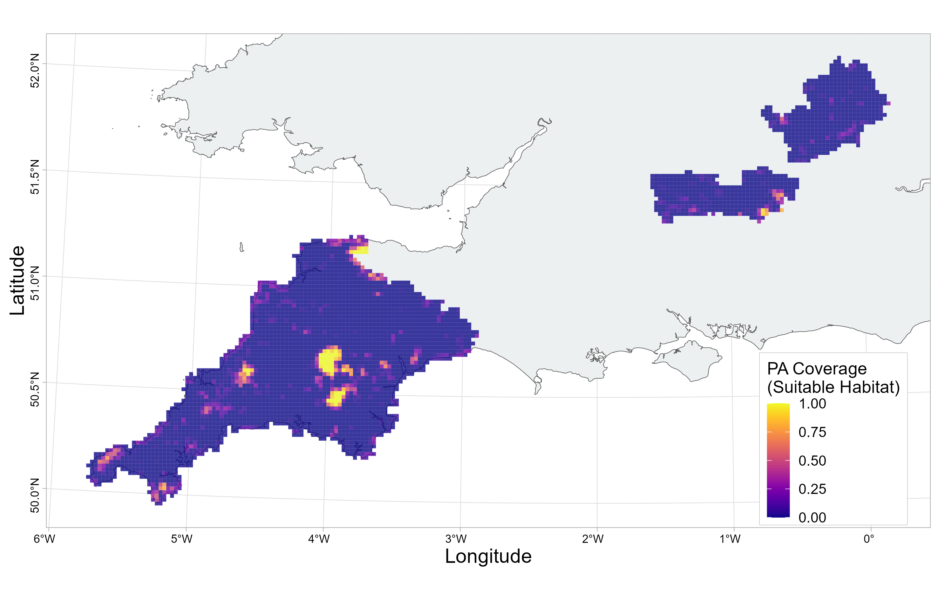
Figure 5: The proportion of each tetrad in Cornwall, Devon, Berkshire and Hertfordshire covered by protected areas that where the dominant habitat was ecologically relevent to pheasants

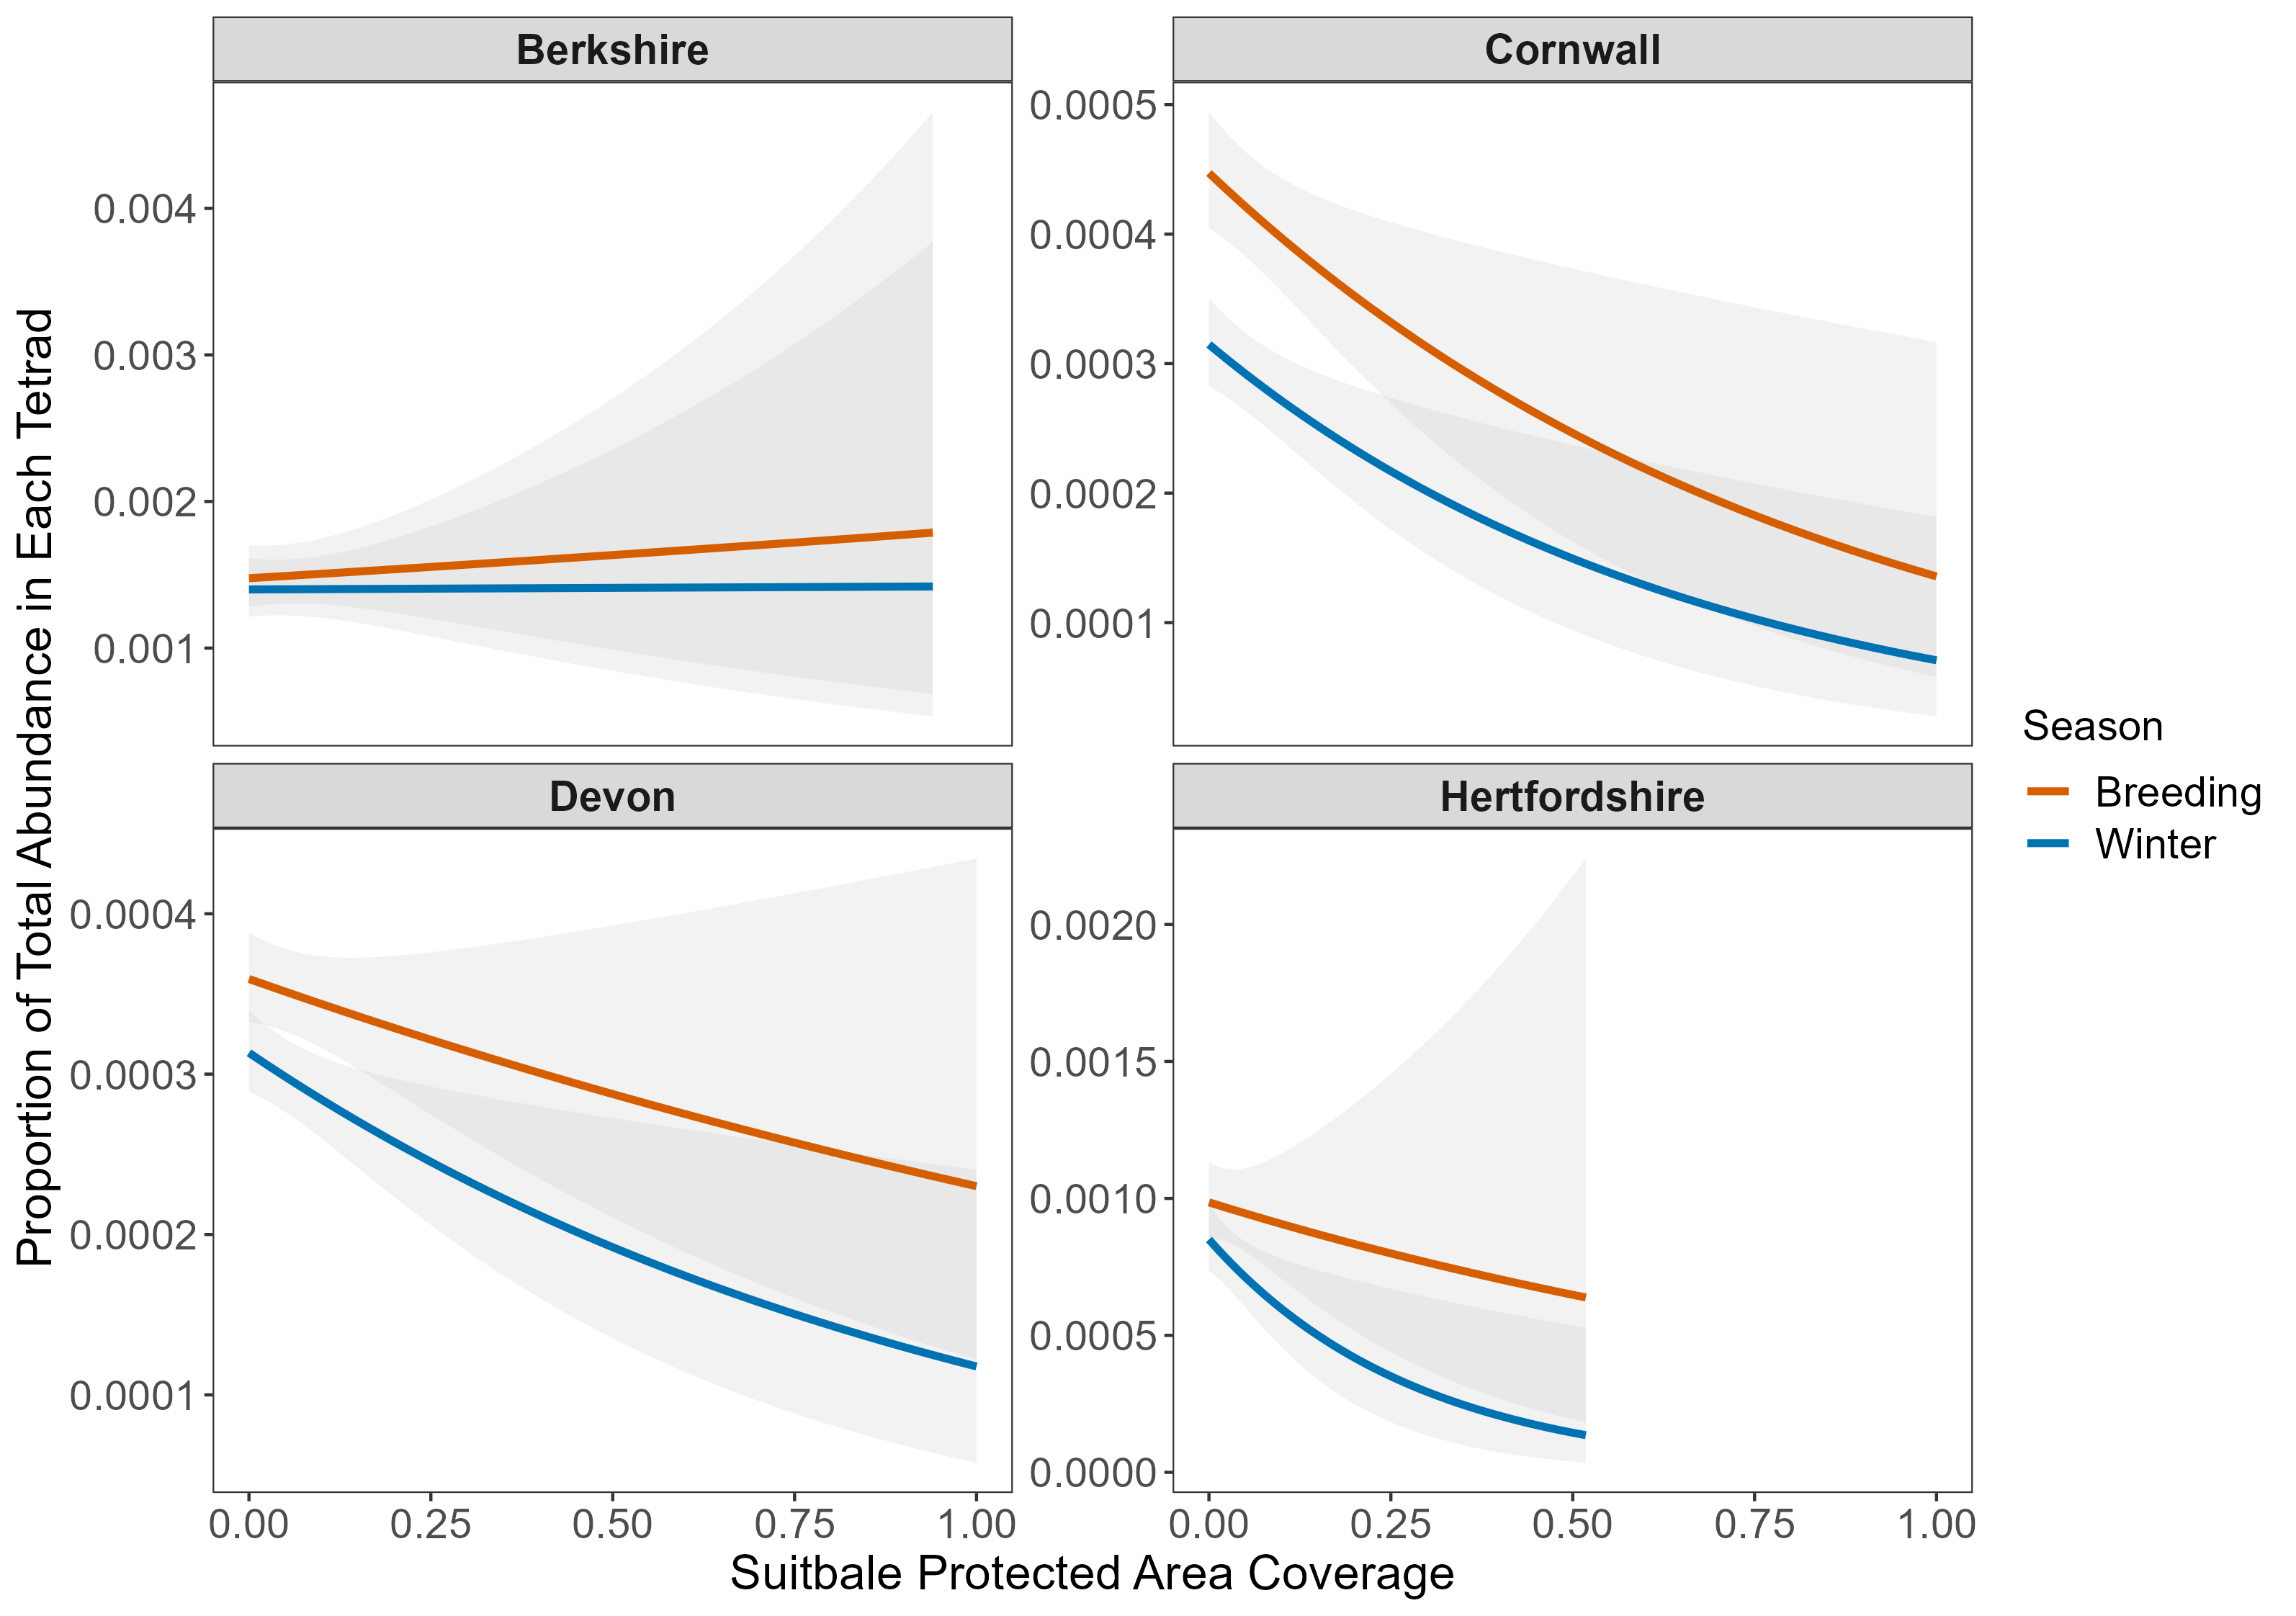
Figure 6: Relationship between relative pheasant abundance and ecologically relevent protected area coverage for winter and summer across four counties. The regression lines for Berkshire and Hertfordshire are censored at the maximum protected area coverage for a tetrad in those counties. Note: the y-axis scales varies by county.

